SHALLOW PARSER FOR HINDI LANGUAGE

By

Akshat Goel | 0909110011
Adiwitiya Singh | 0909110010
Mohit Kumar Singh | 0909110066
Juhi Rajput | 0909110050

Department of Computer Science and Engineering

JSS Academy of Technical Education
C-20/1, Sector 62, NOIDA (U.P.) - 201301
December, 2012

SHALLOW PARSER FOR HINDI LANGUAGE

By

Akshat Goel | 00909110011
Adiwitiya Singh | 09090909110010
Mohit Kumar Singh | 09090909110066
Juhi Rajput | 09090909110050

Submitted to the Department of Computer Science and Engineering
in partial fulfillment of the requirements
for the degree of
Bachelor of Technology
in
Computer Science and Engineering


JSS Academy of Technical Education
U.P. Technical University
December, 2012
DECLARATION
We hereby declare that this submission is our own work and that, to the best of our knowledge and belief, it contains no material previously published or written by another person nor material which to a substantial extent has been accepted for the award of any other degree or diploma of the university or other institute of higher learning, except where due acknowledgment has been made in the text.

Signature:  Name :  Roll No.:  Date : | Signature:  Name :  Roll No.:  Date :
Signature:  Name :  Roll No.:  Date : | Signature:  Name :  Roll No.:  Date :
CERTIFICATE

This is to certify that Project Report entitled “Shallow Parser for Hindi Language” which is submitted by Akshat Goel in partial fulfillment of the requirement for the award of degree B. Tech. in Department of Computer Science and Engineering of U. P. Technical University, is a record of the candidate own work carried out by him under my/our supervision. The matter embodied in this thesis is original and has not been submitted for the award of any other degree.

Supervisor
Date

ACKNOWLEDGEMENT

It gives us a great sense of pleasure to present the report of the B. Tech Project undertaken during B. Tech. Final Year. We owe special debt of gratitude to Assistant Professor, Mrs. Seema Shukla, Department of Computer Science & Engineering, JSS Academy of Technical Education, NOIDA for her constant support and guidance throughout the course of our work. Her sincerity, thoroughness and perseverance have been a constant source of inspiration for us. It is only her cognizant efforts that our endeavors have seen light of the day.
We also take the opportunity to acknowledge the contribution of Professor SS Prasad, Head, Department of Computer Science & Engineering, JSS Academy of Technical Education, NOIDA for his full support and assistance during the development of the project.
We also do not like to miss the opportunity to acknowledge the contribution of all faculty members of the department for their kind assistance and cooperation during the development of our project. Last but not the least, we acknowledge our friends for their contribution in the completion of the project.

Signature:  Name :  Roll No.:  Date : | Signature:  Name :  Roll No.:  Date :
Signature:  Name :  Roll No.:  Date : | Signature:  Name :  Roll No.:  Date :

ABSTRACT

The project creates a shallow parser for the Hindi language. High efficiency shallow parser for Hindi language is needed to serve as the basis for construction of high level tools like Parser. These are required in fields of digitalization and sentiment analysis of texts.
Problem involves the complexity of Hindi language which makes it difficult to create a shallow parser for the same.
Procedure involves use of hierarchy based tree searching for deduction of logical parts of the sentence. Ranking of words is done to determine the best match for the sentence.
Project implements a web based shallow parser for the Hindi language.
Project concludes with development of new highly efficient algorithm for the construction of shallow parser which have been implemented on the Hindi language but can be used on other languages too.

(Example)
TABLE OF CONTENTS Page

DECLARATION ................................................................................................... ii
CERTIFICATE ..................................................................................................... iii
ACKNOWLEDGEMENTS .................................................................................. iv
ABSTRACT ........................................................................................................... v
LIST OF TABLES.................................................................................................. vii
LIST OF FIGURES................................................................................................ viii
LIST OF SYMBOLS .............................................................................................. ix
LIST OF ABBREVIATIONS ................................................................................ x
CHAPTER 1 1
1.1. ................................................................................................................. 5
1.2. ................................................................................................................. 8
CHAPTER 2 ……………………………. ......................................................... 13
2.1. .................................................................................................................. 15
2.2. .................................................................................................................. 17
2.2.1. ......................................................................................................... 19
2.2.2. ......................................................................................................... 20
2.2.2.1. ................................................................................................ 21
2.2.2.2. .......................................................................................... 22
2.3. ................................................................................................................. 23
CHAPTER 3 …………………………….......................................................... 30
3.1. ................................................................................................................ 36
3.2. ................................................................................................................ 39
CHAPTER 4 (CONCLUSIONS) ......................................................................... 40
APPENDIX A ......................................................................................................... 45
APPENDIX B ......................................................................................................... 47
REFERENCES... .................................................................................................... 49
LIST OF TABLES

LIST OF FIGURES

(Example)
LIST OF SYMBOLS

[x] Integer value of x.
≠ Not Equal
∈ Belongs to
€ Euro- A Currency
_ Optical distance
_o Optical thickness or optical half thickness

(Example)
LIST OF ABBREVIATIONS

AAM Active Appearance Model
ICA Independent Component Analysis
ISC Increment Sign Correlation
PCA Principal Component Analysis
ROC Receiver Operating Characteristics
CHAPTER 1
(For non-web based projects)
INTRODUCTION

It is the first chapter of the Report. The purpose of an introduction in the B. Tech Project Report is to justify the reasons for writing about the report. The goal in this section is to introduce the topic to the reader, provide an overview of previous research on the topic, and identify the own hypothesis. The goals just mentioned could, if abused, lead to write an introduction that is pages and pages long. It can be noted here that the introduction should not contain every bit of detail in the report, and it should not include support for the report. An introduction might, however, include the reasons for supporting the report.
In order for readers to trust the writer, the introduction must be well written with few errors. In order to keep readers reading, the writer needs to catch the attention of the reader and write in an interesting way. The unique language enhancement feature may suggest words to strengthen the writing. Strong writing may hold readers' attention.
In addition to well-written English with strong vocabulary, there are a few other strategies to hold readers' attention. It should be noted that to excite the readers' interest, one may also want to sound as though the readers know the topic that are considered in the report. Some of the following strategies in the bullet-list above may help.
• To pose a specific question that can invite the readers to keep reading for the answer-- A provocative question works well to engage readers, so long as it doesn't put them off
• To choose statistics to surprise readers or to go against the common belief about a topic
• To mention a short, interesting anecdote (or story) related to the topic
• To provide an interesting (and relevant) quote
• To develop an unusual or unexpected comparison
It has been observed that the difficulty level to write the Introduction is average and it takes the variable amount of time. Following sub headings are to be included in this chapter depending on the project-
  - Problem Introduction
    - Motivation
    - Project Objective
    - Scope of the Project
  - Related Previous Work
It briefly includes previous work carried out in this field, researching the problem studied, summarization of the results obtained etc
  - Organization of the Report.
It provides the short description of the work reported in each chapter.

CHAPTER 1
(For web based projects)
INTRODUCTION

It is the first chapter of the Report. The purpose of an introduction in the B. Tech Project Report is to justify the reasons for writing about the report. The goal in this section is to introduce the topic to the reader, provide an overview of previous research on the topic, and identify the own hypothesis. The goals just mentioned could, if abused, lead to write an introduction that is pages and pages long. It can be noted here that the introduction should not contain every bit of detail in the report, and it should not include support for the report. An introduction might, however, include the reasons for supporting the report.
In order for readers to trust the writer, the introduction must be well written with few errors. In order to keep readers reading, the writer needs to catch the attention of the reader and write in an interesting way. The unique language enhancement feature may suggest words to strengthen the writing. Strong writing may hold readers' attention.
In addition to well-written English with strong vocabulary, there are a few other strategies to hold readers' attention. It should be noted that to excite the readers' interest, one may also want to sound as though the readers know the topic that are considered in the report. Some of the following strategies in the bullet-list above may help.
• To pose a specific question that can invite the readers to keep reading for the answer-- A provocative question works well to engage readers, so long as it doesn't put them off
• To choose statistics to surprise readers or to go against the common belief about a topic
• To mention a short, interesting anecdote (or story) related to the topic
• To provide an interesting (and relevant) quote
• To develop an unusual or unexpected comparison
It has been observed that the difficulty level to write the Introduction is average and it takes the variable amount of time. Following sub headings are to be included in this chapter depending on the project-
  - Problem Introduction
    - Purpose
    - Project Objective/ Vision
    - Functional Requirements (at least eight)
    - Non-functional Requirements (at least four)
    - Optional Features
    - User interface priorities
    - Reports
    - Final Deliverables
  - Related Previous Work
It briefly includes previous work carried out in this field, researching the problem studied, summarization of the results obtained etc
  - Organization of the Report.
It provides the short description of the work reported in each chapter.
CHAPTER 2
(For non-web based projects)
Literature Survey
(LITERATURE SURVEY FORMAT FOR NON-WEB BASED PROJECTS)
- A brief description of what is studied in the survey should be given in a paragraph of 6-10 lines (approx.) this paragraph should not contain any title.
- Then you can elaborate on each technique/algorithm/ technology depending on your project section wise. For example if literature survey is for face recognition then all existing approaches should be mentioned in a separate section.
- Each section should contain a heading and should be numbered. It can also contain images, formulae, flow chart and tabular data that are needed for explanation. Each section size should not exceed 1 to 1.5 pages.
- Use citations from the References section where ever required-
Example- A pun, or paronomasia, is a form of word play that deliberately exploits ambiguity between similar-sounding words for humorous or rhetorical effect. ^{[1]} (If the contents are taken from reference 1 of References section).
All citations must be referred.
- Any included image, formula, flow chart or tabular data should be numbered and should be referred in the respective section. Tables numbering should appear on the top of table and figure numbering should be below the figure.
- At the end of the literature survey chapter, include a summary section with the heading SUMMARY. In this section sum up the above studied techniques/algorithms/ technologies paragraph wise.

CHAPTER 2

(For Web Based Projects)

Software Requirement Specification

Describe the general factors that affect the product and its requirements. This section does not state specific requirements. Instead, it provides a background for those requirements, which are defined in section 3, and makes them easier to understand. In a sense, this section tells the requirements in plain English for the consumption of the customer. Section3 will contain a specification written for the developers.

2.1 Product Perspective

Put the product into perspective with other related products. If the product is independent and totally self-contained, it should be so stated here. If the SRS defines a product that is a component of a larger system, as frequently occurs, then this subsection relates the requirements of the larger system to functionality of the software and identifies interfaces between that system and the software. If you are building a real system, compare its similarity and differences to other systems in the marketplace. If you are doing a research-oriented project, what related research compares to the system you are planning to build.

A block diagram showing the major components of the larger system, interconnections, and external interfaces can be helpful. This is not a design or architecture picture. It is more to provide context, especially if your system will interact with external actors. The system you are building should be shown as a black box. Let the design document present the internals.

The following subsections describe how the software operates inside various constraints.

2.1.1 System Interfaces

List each system interface and identify the functionality of the software to accomplish the system requirement and the interface description to match the system. These are external systems that you have to interact with. For instance, if you are building a business application that interfaces with the existing employee payroll system, what is the API to that system that designer’s will need to use?

2.1.2 Interfaces

Specify:
- The logical characteristics of each interface between the software product and its users.
- All the aspects of optimizing the interface with the person who must use the system

This is a description of how the system will interact with its users. Is there a GUI, a command line or some other type of interface? Are there special interface requirements? If you are designing for the general student population for instance, what is the impact of ADA (American with Disabilities Act) on your interface?

2.1.3 Hardware Interfaces

Specify the logical characteristics of each interface between the software product and the hardware components of the system. This includes configuration characteristics. It also covers such matters as what devices are to be supported, how they are to be supported and protocols. This is not a description of hardware requirements in the sense that “This program must run on a Mac with 64M of RAM”. This section is for detailing the actual hardware devices your application will interact with and control. For instance, if you are controlling X10 type home devices, what is the interface to those devices? Designers should be able to look at this and know what hardware they need to worry about in the design. Many business type applications will have no hardware interfaces. If none, just state “The system has no hardware interface requirements” If you just delete sections that are not applicable, then readers do not know if: a. this does not apply or b. you forgot to include the section in the first place.

2.1.4 Software Interfaces

Specify the use of other required software products and interfaces with other application systems. For each required software product, include:
- Name
- Mnemonic
- Specification number
- Version number
- Source

For each interface, provide:
- Discussion of the purpose of the interfacing software as related to this software product
- Definition of the interface in terms of message content and format

Here we document the APIs, versions of software that we do not have to write, but that our system has to use. For instance if your customer uses SQL Server 7 and you are required to use that, then you need to specify i.e.
2.1.4.1 Microsoft SQL Server 7. The system must use SQL Server as its database component. Communication with the DB is through ODBC connections. The system must provide SQL data table definintions to be provided to the company DBA for setup.

A key point to remember is that you do NOT want to specify software here that you think would be good to use. This is only for customer-specified systems that you have to interact with. Choosing SQL Server 7 as a DB without a customer requirement is a Design choice, not a requirement. This is a subtle but important point to writing good requirements and not over-constraining the design.

2.1.5 Communications Interfaces

Specify the various interfaces to communications such as local network protocols, etc. These are protocols you will need to directly interact with. If you happen to use web services transparently to your application then do not list it here. If you are using a custom protocol to communicate between systems, then document that protocol here so designers know what to design. If it is a standard protocol, you can reference an existing document or RFC.

2.1.6 Memory Constraints

Specify any applicable characteristics and limits on primary and secondary memory. Don’t just make up something here. If all the customer’s machines have only 128K of RAM, then your target design has got to come in under 128K so there is an actual requirement. You could also cite market research here for shrink-wrap type applications “Focus groups have determined that our target market has between 256-512M of RAM, therefore the design footprint should not exceed 256M.” If there are no memory constraints, so state.

2.1.7 Operations

Specify the normal and special operations required by the user such as:
- The various modes of operations in the user organization
- Periods of interactive operations and periods of unattended operations
- Data processing support functions
- Backup and recovery operations

(Note: This is sometimes specified as part of the User Interfaces section.) If you separate this from the UI stuff earlier, then cover business process type stuff that would impact the design. For instance, if the company brings all their systems down at midnight for data backup that might impact the design. These are all the work tasks that impact the design of an application, but which might not be located in software.

2.1.8 Site Adaptation Requirements

In this section:
- Define the requirements for any data or initialization sequences that are specific to a given site, mission, or operational mode
- Specify the site or mission-related features that should be modified to adapt the software to a particular installation

If any modifications to the customer’s work area would be required by your system, then document that here. For instance, “A 100Kw backup generator and 10000 BTU air conditioning system must be installed at the user site prior to software installation”.
This could also be software-specific like, “New data tables created for this system must be installed on the company’s existing DB server and populated prior to system activation.” Any equipment the customer would need to buy or any software setup that needs to be done so that your system will install and operate correctly should be documented here.

2.2 Product Functions

Provide a summary of the major functions that the software will perform. Sometimes the function summary that is necessary for this part can be taken directly from the section of the higher-level specification (if one exists) that allocates particular functions to the software product.

For clarity:
- The functions should be organized in a way that makes the list of functions understandable to the customer or to anyone else reading the document for the first time.
- Textual or graphic methods can be used to show the different functions and their relationships. Such a diagram is not intended to show a design of a product but simply shows the logical relationships among variables.

AH, Finally the real meat of section 2. This describes the functionality of the system in the language of the customer. What specifically does the system that will be designed have to do? Drawings are good, but remember this is a description of what the system needs to do, not how you are going to build it. (That comes in the design document).

2.3 User Characteristics

Describe those general characteristics of the intended users of the product including educational level, experience, and technical expertise. Do not state specific requirements but rather provide the reasons why certain specific requirements are later specified in section 3.

What is it about your potential user base that will impact the design? Their experience and comfort with technology will drive UI design. Other characteristics might actually influence internal design of the system.

2.4 Constraints

Provide a general description of any other items that will limit the developer's options. These can include:

(1) Regulatory policies
(2) Hardware limitations (for example, signal timing requirements)
(3) Interface to other applications
(4) Parallel operation
(5) Audit functions
(6) Control functions
(7) Higher-order language requirements
- Signal handshake protocols (for example, XON-XOFF, ACK-NACK)
- Reliability requirements
(10) Criticality of the application
(11) Safety and security considerations

This section captures non-functional requirements in the customers language. A more formal presentation of these will occur in section 3.

2.5 Assumptions and Dependencies

List each of the factors that affect the requirements stated in the SRS. These factors are not design constraints on the software but are, rather, any changes to them that can affect the requirements in the SRS. For example, an assumption might be that a specific operating system would be available on the hardware designated for the software product. If, in fact, the operating system were not available, the SRS would then have to change accordingly.

This section is catch-all for everything else that might influence the design of the system and that did not fit in any of the categories above.

2.6 Apportioning of Requirements.

Identify requirements that may be delayed until future versions of the system. After you look at the project plan and hours available, you may realize that you just cannot get everything done. This section divides the requirements into different sections for development and delivery. Remember to check with the customer – they should prioritize the requirements and decide what does and does not get done. This can also be useful if you are using an iterative life cycle model to specify which requirements will map to which interation.

  - Use case

Use case Model
- Some Guide Lines for use cases
- Place Your Primary Actor(S) In The Top-Left Corner Of The Diagram
- Draw Actors To The Outside Of A Use Case Diagram
- Name Actors With Singular, Business-Relevant Nouns
- Associate Each Actor With One Or More Use Cases
- Actors Model Roles, Not Positions
- Use <<system>> to Indicate System Actors
- Actors Don’t Interact With One Another
- Introduce an Actor Called “Time” to Initiate Scheduled Events
- Associations are depicted as lines connecting two modeling elements with an optional open-headed arrowhead on one end of the line indicating the direction of the initial invocation of the relationship. Generalizations are depicted as a close-headed arrow with the arrow pointing towards the more general modeling element.

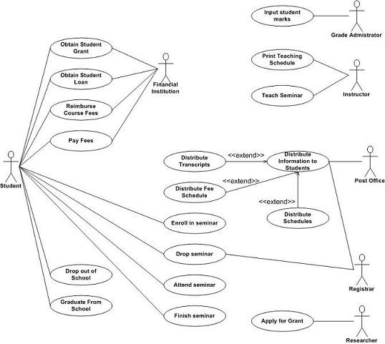
Figure 2.1 Use case model examples
2.7.2 Use Case Diagram (you can use either use case diagram or scenario)
Registration Process Example
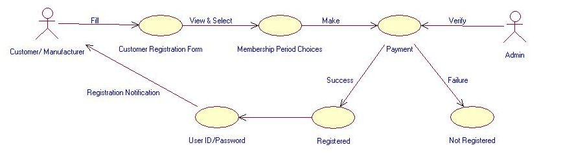
Figure 2.2 Use case diagram example

2.7.3 Use Case Scenario (Following details can be provided for a use case scenario)

Use Case Element | Description
Use Case Number | ID to represent your use case
Application | What system or application does this pertain to
Use Case Name | The name of your use case, keep it short and sweet
Use Case Description | Elaborate more on the name, in paragraph form.
Primary Actor | Who is the main actor that this use case represents
Precondition | What preconditions must be met before this use case can start
Trigger | What event triggers this use case
Basic Flow | The basic flow should be the events of the use case when everything is perfect; there are no errors, no exceptions. This is the "happy day scenario". The exceptions will be handled in the "Alternate Flows" section.
Alternate Flows | The most significant alternatives and exceptions

Sequence diagrams ( Example for Registration Process)
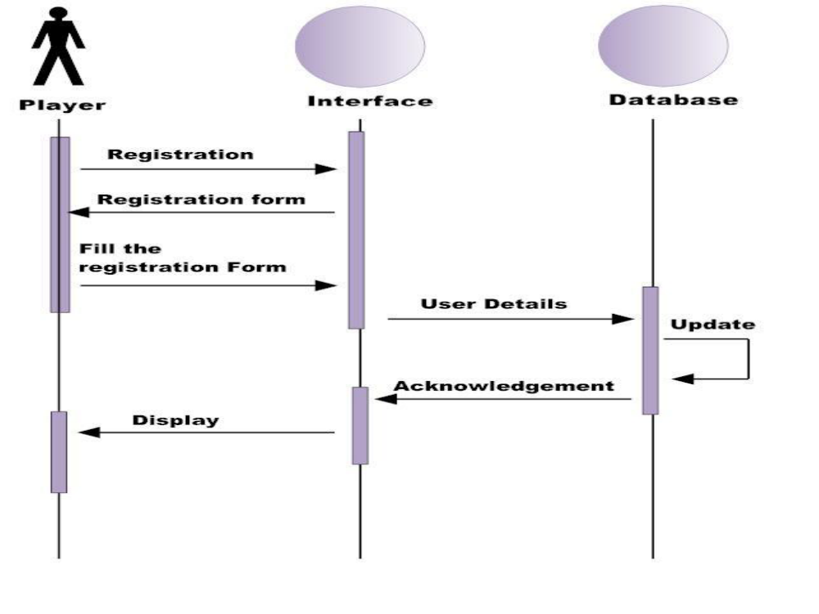
Figure 2.3 Sequence Diagram example
CHAPTER 3
(For non-web based projects)
System Design and Methodology
  - System Design
    - System Architecture /DiagrammaticalView
    - DFD, Class Diagram, flow charts, ER Diagrams (which ever applicable depending on the project)
  - Algorithm(s)

(if required, add any other section applicable for the methods and approaches you have followed. The structure of this chapter may be defined by the Supervisor)

Chapter 3
(For Web-Based Projects)

System Design

System Design should include the following sections (Refer each figure or table in some text). Figure number should be provided below the figure and the table numbering should be provided above the table.

Architecture diagrams
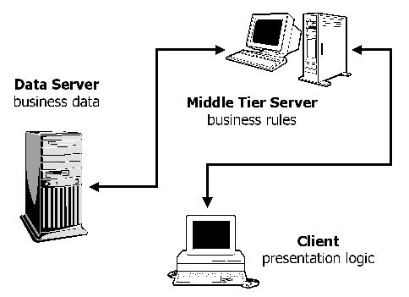
Figure 3.1 3-Tier Architecture Diagram example

Class diagrams
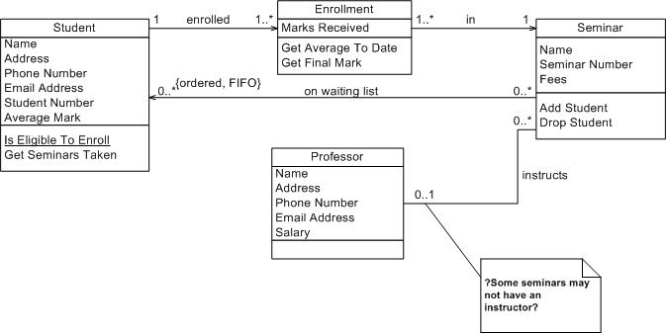
Figure 3.2 Class Diagram example

  - Data Flow Diagram (Example of a registration process)
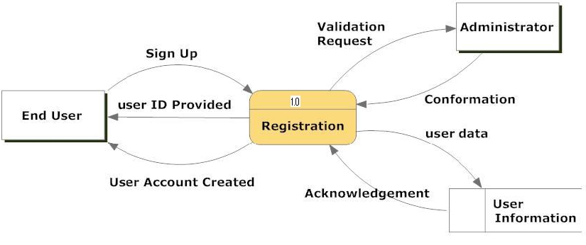
Figure 3.3 Data Flow Diagram example

  - Activity Diagram (Example for Registration and Login)
Name of Activity diagram: Registration and login.
Description: To create user’s account and sign in for playing chess.
Normal flow of events:
All the details regarding profile are asked from the user.
Details will be saved.
User id is generated.
User enters the id and password for access.
Alternate flow of events:
A message appears for wrong login id and password.
Post condition:
A login id is generated with its details.
User is logged in.
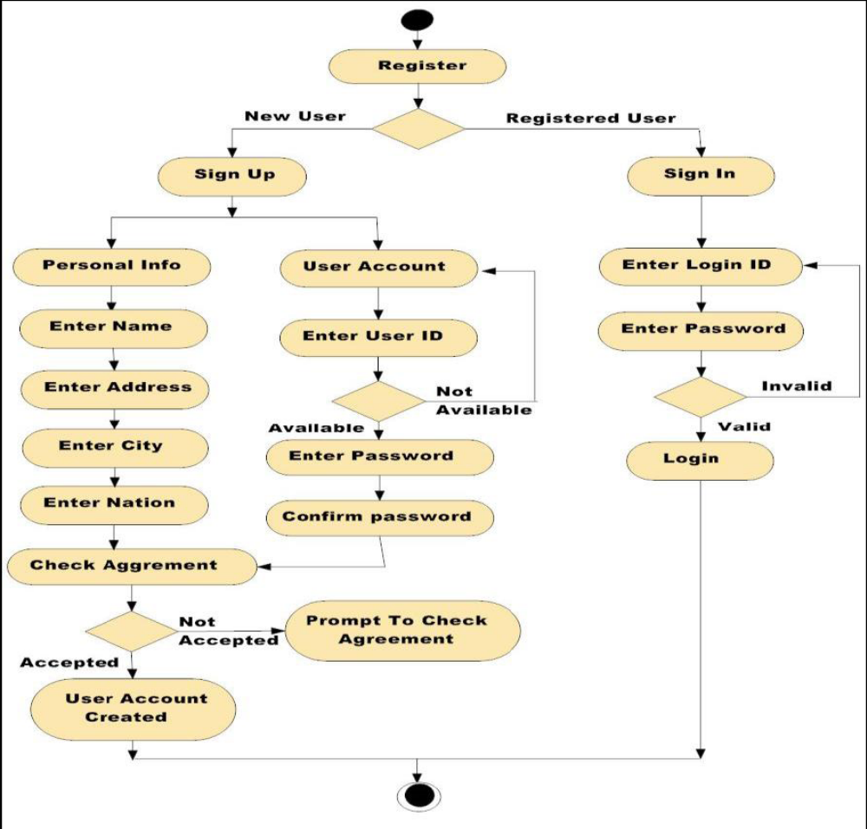
Figure 3.4 Activity Diagram example

ER Diagrams

Database schema diagrams

CHAPTER 4
Conclusion

- Mention in a paragraph what you have achieved in last six months.
- Should clearly state the agenda for the next semester (by means of PERT chart).
Appendix
If there is material that should be in the project report but which would break up the flow or bore the reader unbearably, include it as an appendix. Some things which are typically included in appendices are: important and original computer programs, data files that are too large to be represented simply in the results chapters, pictures or diagrams of results which are not important enough to keep in the main text. Thus in the appendix, one may include
- All data used in the report
- Reference data/materials not easily available
- Tables (where more than 1-2 pages)
- Calculations (where more than 1-2 pages)
- All key articles
- List of all additional resource materials
- List of equipment used for an experiment or details of complicated procedures.
- In case of more than one appendix , they should be numbered as Appendix A, Appendix B etc

References
Thumb rules followed to refer some one’s work are given below.
- Cite all ideas, concepts, text, data that are not own by the project group
- If author makes a statement, he must back it up with his own data or a reference
- All references cited in the text must be listed
- List all references cited in the text in alphabetical
- Follow the format or citation style as discussed in chapter 4.
(Example of References using the Numeric System)
Examples of Journal Article referencing:
1. Drucker, D. C., "Photoelastic Separation of Principal Stresses by Oblique Incidence", Journal of Applied Mechanics, Vol. 65, pp. 156-160, 1943.
2. Maiers, J., and Sherif, Y. S. , "Application of Fuzzy Set Theory," IEEE Transactions on Systems, Man, and Cybernetics, Vol. SMC-15, No.1, pp. 41-48, 1985.
Example of Book referencing:
3. Doe, N., Control System Principles, New York: John Wiley, 1999.
Example of Referencing of an Article in a Book:
4. Hwang, C. J., "Rule-based Process Control," in E. Kumarmangalam and L. A. Zadeh (Eds.), Approximate Reasoning in Intelligent Systems, Decision and Control, pp. 145-158, Oxford: Pergamon Press, 1987.
Example of referencing of a B. Tech. Report:
5. Nayak, T., "Application of Neural Networks to Nuclear Reactors," M.Sc. Report, U.P. Technical University, 2005.
Example of referencing of a Ph. D. Dissertation:
6. Muskìn, H. L., "Development of A Knowledge-Based System for a Nuclear Power Plant," Ph.D. Dissertation, U. P. Technical University, 2003.
Example of referencing of a Conference Paper :
7. Lokhande, R., Arya, K. V., and Gupta, P., "Identification of Parameters and Restoration of Motion Blurred Images", Proceedings of the 2006 ACM Symposium on Applied Computing (SAC 2006), pp. 89-95, Dijon, France, April 2- 7, 2006.
Example of referencing of a Paper presented at Conference but not Published :
8. Lokhande, R., and Gupta, P., "Identification of Parameters of Motion Images", presented at 5th International Conference on Cyber Systems, New Delhi, India, April 12- 17, 2004
Example of referencing of a Report [Technical, Internal, or Memoranda]: :
9. Das, A. R., Murthy D., and Badrinath J., A Comparison of Different Biometrics Traits, RSRE Memorandum No. 4157, RSRE Malvern, 2001.
Example of referencing of a Manual
10. Bell Telephone Laboratories Technical Staff, Transmission System for Communications, Bell Telephone Laboratories, 1995.
Example of referencing of a Class Note
11. "Signal integrity and interconnects for high-speed applications," class notes for ECE 497- JS, Department of Electrical and Computer Engineering, University of Illinois at Urbana- Champaign, Winter 1997.
Example of referencing of a Private Communication
12. Banerjee, T., (Private Communication), 1998
Example of referencing of an Article from Internet
13. Biometrics Group, Indian Institute of Technology Kanpur, "Multimodal Biometrics System," December 2006, http://www.cse.iitk.ac.in/users/biometrics.html
14. Gupta, P. (pg@iitk.ac.in), "Biometrics System," Usenet post to sci.electronics.design, July 4, 2007.
Example of referencing of an Article from Catalog
15. Catalog No. MWM-1, Microwave Components, M. W. Microwave Corp., Brooklyn, NY
Example of referencing of an Article from Application Note
16. Hewlett-Packard, Appl. Note 935, pp. 25-29.
Example of referencing of an Article from Application Note
- Kar, K. and Majumder, D., "Fuzzy Controller Component," U. S. Patent 23,160,040, December 21, 2006.

TEXT PROCESSING INFORMATION

It is important to note that type format of all reports should be uniform. So there is a need to follow some guidelines on typesetting and other aspects. Some of such guidelines are given below.
1. The original copy shall be typed on 75 or 80 gr./m2 white paper. All photocopies shall be run on the same grade of paper. Size of paper shall be 210 x 297 mm, i.e. A4.
2. Only Near Letter Quality or sharper dot matrix printer or Laser printer and Ink Jet printer and electrical typewriter outputs are acceptable. In case of dot matrix printers or a typewriter, black ribbon must be used and replenished as frequently as necessary to maintain clear and high contrast constant density copy throughout the report.
3. As a character font, one should use Times new roman preferably (Times, Times Roman, Courier, Geneva, Helvetica or equivalent) which are available in most word processors. The font size must be 12 point in the text and at least 8 point in the figures. However, if a typewriter is used, then typing must be done on an electric typewriter and with an Elite, Pica, or Letter Gothic typeface, and preferably with a carbon film ribbon to avoid a fading effect.
4. Whenever titles and headings are to be centered the centering shall be such that 112 mm. from the left edge of the paper or 98 mm. for the right edge of the paper is the center point of the title or heading.
5. Margins of pages shall conform to the following specifications.
a. Left margin - 3 1/2 cm. from edge of paper.
b. Right margin - 2 cm. from edge of paper.
c. Top margin - 3 1/2. from edge of paper.
d. Bottom margin - 2 cm. from edge of paper.
The above margins shall be observed on charts, graphs, tables, and drawings. Folded papers will not be accepted unless there is absolutely no other way for the material to be presented. The text must be justified within these margins.
6. Spacing of the text material shall be 1.5 with the following exceptions:
a. Footnotes - single spacing
b. Long biographical quotes - single spacing
c. Extensive quotations - single spacing and indented eight (8) spaces relative to the text material.

7. Headings used in the report shall conform to the following rules:
a. Chapter Headings - CHAPTER 1,CHAPTER 2, CHAPTER 3 etc. .
(1) Must begin a new page and be centered using the Font Size 18 with Bold Fold. Omit period at the end of the heading.
(2) Must be typed in upper case letters.
(3) Chapter headings are to be titled names that reflect content of the text that follows.
(4) It should be centered and Font Size to be used is 18 with Bold Face.
(5) Must be typed in upper case letters.
(6) Provide 3 blank lines after the chapter name.
b. Second Headings - 2.1, 2.2, 2.3, etc.
(1) Must be towards left margin and be typed in capital and lower case letters; i.e., the first letter of each word except conjunctions, prepositions, and articles must be a capital letter. Omit period at the end of heading.
(2) The letter designation of the heading shall be followed by a period and two blank spaces.
(3) Must be three spaces below preceding text and two spaces ahead of succeeding text.
(4) Font Size to be used is 14 with Bold Face.
(5) In case it is found that first line of the succeeding text starts from the next page, then this heading should start from the next page using page break.
c. First sub-headings - 2.2.1, 2.2.2 , etc.
(1) Must be typed on separate lines beginning at the left margin line of the text, but need not begin a new page.
(2) Must be typed in capital and lower case letters except conjunctions, prepositions, and articles.
(3) The number designation of the heading shall be followed by a period and two spaces. Omit period at the end of the heading.
(4) Must be separated from the succeeding text by three spaces.
(5) Font Size to be used is 12 with Bold Face.
(6) In case it is found that first line of the succeeding text starts from the next page, then this sub-heading should start from the next page using page break.
d. Second sub-headings- 2.2.1.1, 2.2.1.2 etc.. (second sub-headings must not be included). In case required, this must be italic and bold and text should start in the same line. (As shown below)
Second sub-heading Second sub-headings must not be included…..
8. Figures and Tables: Ideally, every result claimed in the text should be documented with data, usually data presented in tables or figures. If there are no data provided to support a given statement of result or observation, one should consider adding more data, or deleting the unsupported "observation." Examine figure(s) or table(s) pertaining to the result(s).
Author should assess whether:
- the data support the textual statement
- the data contradict the textual statement
- the data are insufficient to prove
The actual figures and tables should be embedded/inserted in the text, generally on the page following the page where the figure/table is first cited in the text. All figures should be numbered and cited consecutively in the text as Figure 2.1, Figure 2.2, to indicate the first and second figures in Chapter 2 respectively. Similarly it is the case with tables such as Table 3.1, Table 3.2, etc.
A caption for each figure and table is to be given with proper citation about reference, data sources, etc. and by highlighting the key findings. One should include an index figure (map) showing and naming all locations discussed in the report.
Author is always encouraged to make his own figures, including cartoons, schematics or sketches that illustrate the derived processes. He should see all his figures keeping in mind that:
- Each figure is self-explanatory.
- Axes of figures are labeled and the units, if used, are indicated.
- Uncertainty are shown in data with error bars.
- If the data are fitted by a curve, its goodness of fit should be determined.
- Junk data must be eliminated.
- Non-data ink must be eliminated.
- Redundant data ink must be eliminated.
- An effort has to be made to increase data density by eliminating non-data bearing space.
- Whether data is sparse set that could better be expressed as a table.
- Whether the figure distorts the data in any way.
- Whether the data are presented in context.
- Whether its caption guides one’s eye to the "take-home lesson" of the figure.
Figures should be oriented vertically, in portrait mode, wherever possible. If they must be oriented horizontally, in landscape mode, so that one can read them from the right, not from the left, where the binding will be. Examples are given below.
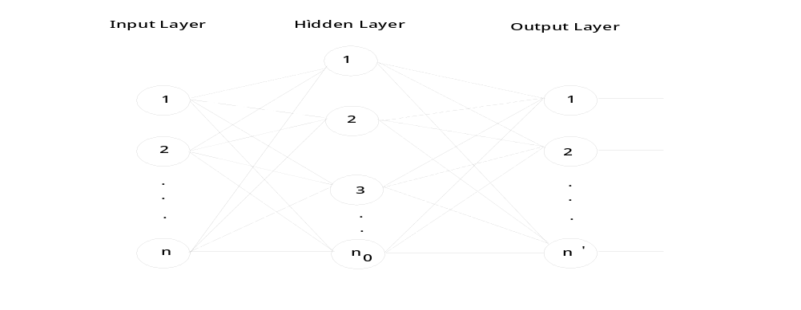
Figure 2.2. A typical neural network.

TABLE 9.12. Comparison Of Various Data Structures.
Operation | Sequential List | Linked List | AVL-Tree
Search | O(log n) | O(n) | O(log n)
Delete | O(n) | O(1) | O(log n)
Insert | O(n) | O(1) | O(log n)

9. Footnotes, Specially Designated Expressions and Paragraphs
a. Footnotes (Footnotes should be used only if absolutely necessary): Footnote references shall be indicated in the text by an Arabic number placed superior to the of the text and immediately following the word phrase or sentence which the footnote concerns.
Footnotes shall be sequential for each page and for the entire report.
Footnotes shall be placed at the bottom of the page on which they are indicated. They shall be indented from the margin line of the text by eight spaces and placed under a broken line made of 15 dashes.
Footnotes shall be single spaced typing.
b. Specially Designated Expressions: Specially designated expressions usually mean equations, formulas, etc.
Specially designated expressions shall be centered on the page according to instruction number 6 and shall be set below the preceding text and before the succeeding text by three line spaces.
The expressions shall be identified by an Arabic number in parenthesis placed opposite the expression and in line with the right margin of the text. They should be numbered in each chapter in the order of their appearance together with the chapter number, e.g. (6.14). The expression in the body of the report can be referred to (6.14).
Avoid to start a sentence in the text with the expression number. This can be avoided by using changing the voice.
10. Pagination and Paragraphs: Each page in the report or dissertation is expected to bear a number. Only one side of the paper may be used. The following plan should be used exclusively:
a. The preliminary section, including the title page; copyright page, if any; foreword, preface, or acknowledgements; table of contents; etc., should be numbered, using lower case Roman Numerals, e.g., i, ii, iii, etc. The title page counts as Page i, but the number does not appear. The sequence of the preliminary section is as follows:
Title Page ........................................................ Page i - number does not appear
Declaration...................................................... Page ii
Certificate........................................................ Page iii
Acknowledgements......................................... Page iv
Abstract ........................................................... Page v
Table of Contents ........................................... Page vi
List of Tables.................................................. Page vii
List of Figures................................................. Page viii
List of Symbols .............................................. Page ix
For the remainder of the report, Arabic numbers are used. Each page must be numbered. Page numbers are to be placed 2 centimeters from the top and right hand margins on the pages. All pages for illustrations, tables, appendices, bibliography, etc are included. Use of suffixes, such as 25a, 25b ... are not allowed. The numbering in the main body should begin with Page 1 and run consecutively to the last page. No punctuation, such as dash or a period, should accompany the page number.
b. Paragraphs: A new paragraph must not begin at the bottom of a page if there is not sufficient space for at least two lines.
11. Size of Thesis: There is no limit on the number of pages to be used in the report. But it should be complete in all respect. However it is expected that the number of pages in the report will not exceed 100 pages of typed matter reckoned from the First page of Chapter 1 to the last page of the Appendix.
12. Binding Specifications: Spiral Bound for VII Sem
13. Number of Copies: One hard copy to be submitted at the end of VII Semeste

CITATION STYLE

In a project report there is a need to make references in the text, and relate them to notes, or to a list of bibliographical references, at the end of the description of the work. A number of elements must be present for a document to be identifiable with certainty. It is better to give extra or redundant information than to omit vital features.

- Citation of Books
The standard format or citation Style for a book is
- author(s)
- title
- edition (if applicable)
- place of publication
- publisher
- date
Some citation styles omit place of publication, but it is useful, e.g. when filling out inter-library loan requests, where it can simplify and limit the searching process. Examples (books) are given below.
one author: Williams, G. State and Society in. Onco State, Nigeria, Afrographika, 1980.

two authors: Phizacklea, A & Miles, R. Labour and Racism. London, Routledge & Kegan Paul, 1980.

3 + authors: O'Donovan, P., et al. The United States. Amsterdam, Time-Life International, 1966.
('et al.' is a Latin abbreviation meaning 'and others'.)

no authors: Generals and Tupamaros: The Struggle for Power in Uruguay, 1969-1973.London, Latin America Review of Books, 1974.
one editor: Oyediran, O.,ed. Nigerian Government and Politics under Military Rule, 1966-1979. London, Macmillan, 1979. (Contemporary African Issues)
('Contemporary African Issues' is a 'series note'.)

To some extent, the details of punctuation are up to the author as long as he is consistent. He may, for instance, decide to write authors' names in upper case (capitals), or to give their forenames in full ,if it is available.
The purpose of using italics is not just to give emphasis, but to show which element in the citation is a separately published unit. It is especially important when one is citing a section (an article, a paper, or a chapter) in a collection or other composite work, e.g.
Watson, R. 'Racial and Ethnic Relations', in Anderson, R. and Sharrock, W.W., eds., Applied Sociological Perspectives. London: Allen & Unwin, 1984. pp.3-65.
If one makes this kind of reference correctly, the reader will immediately know what is the book to look for (i.e. Anderson and Sharrock) and not waste time searching for a non-existent (or a different) work with the title, Racial and Ethnic Relations. Inverted commas are often used to signal a part or contribution in a larger work - they show that it is not separately published in its own right, and it is not good practice to use them to show a book title.
- Citation of Periodicals
The same principles that apply to a book apply when he is citing articles from periodicals - journals, magazines, newspapers, reviews, etc.
For an article format is given below.
- author(s)
- title of the article
- title of the periodical, or its accepted abbreviation.
- date , volume, and part number of the issue in which it appears
- page numbers

Examples are given below.

Davis, R.D. 'Sludge disposal - keeping it safe'. Water and waste treatment, 1984, 27 (9) 38-42
or
Zlotnik, M. D. 'Chernenko succeeds'. Problems of Communism 33 (2) March-April 1984, pp.17-31.
The detail of order and punctuation may vary between one writer and another, or with the same writer on different occasions; the important thing is to decide firmly at the start how the author is going to proceed, and stick to that style. Publishers of books and journals have their own 'house-styles', and editorial staff to apply them rigorously; for these purposes, clarity and consistency are enough -- one should not cite something unless the author is quite sure, he has enough information for a reader to identify it. It is not necessary to use Roman numerals for volume numbers, even if the periodical the author is citing uses them itself, or if he has seen them in a citation elsewhere. Single inverted commas are used again here, to show which is the article, and which is the periodical title.
It is sometimes needed to cite an issue by date, rather than part number, even if it has one, e.g.
Wood, Nick. 'Multiracial Study Pioneer in Grenada Coup'. Times Educational Supplement, 28th October 1983, p.1.
or to cite the whole of an issue, rather than an article:
Curriculum, 1980, vol 1(3).

